|  |  |  |
| --- | --- | --- |
|  |  | |
|  | | |
|  | |  |
|  | | |
| Huawei eSight for vROps Plug-in | |  |
| **User Guide** | |  |
|  | | |
| V1.2.4 | |  |
|  | | |
| Issue:04  Date:2021-01-27 | |  |
|  | | |
|  | Copyright © Copyright Holder. All rights reserved. | |

|  |  |  |  |
| --- | --- | --- | --- |
|  |  | | |
|  | | | |
|  | **Notice** |  | |
|  | The information in this document is subject to change without notice. Every effort has been made in the preparation of this document to ensure accuracy of the contents, but all statements, information, and recommendations in this document do not constitute the warranty of any kind, express or implied. |  |

Contents

Preface 1

1 Overview 1-1

2 Installing and Uninstalling the Huawei vROps Plug-in 2-1

2.1 Installing the Huawei vROps Plug-in 2-1

2.2 Uninstalling the Huawei vROps Plug-in 2-2

3 Configuring an eSight Instance 3-1

3.1 Adding an eSight Instance 3-1

3.2 Modifying an eSight Instance 3-4

3.3 Deleting an eSight Instance 3-6

4 Querying Server Information 4-1

4.1 Querying the Server List 4-1

4.2 Querying Component Information 4-3

4.3 Adding a Component View 4-4

4.4 Locating Alert Information 4-10

5 Querying the Huawei vROps Plug-in Version 5-1

6 FAQs 6-1

6.1 Connection Test Failed When Adding an eSight 6-1

7 Getting Help 7-1

7.1 Collecting Fault Information 7-1

7.2 Preparing for Debugging 7-1

7.3 Using Product Documentation 7-2

7.4 Obtaining Technical Support 7-2

Preface

Overview

This guide describes how to install and maintain Huawei vRealize Operations Manager (vROps) plug-in.

Intended Audience

This document is intended for:

* Technical support engineers
* System maintenance engineers

Symbol Conventions

The symbols that may be found in this document are defined as follows.

| Symbol | Description |
| --- | --- |
|  | Indicates an imminently hazardous situation which, if not avoided, will result in death or serious injury. |
|  | Indicates a potentially hazardous situation which, if not avoided, could result in death or serious injury. |
|  | Indicates a potentially hazardous situation which, if not avoided, may result in minor or moderate injury. |
|  | Indicates a potentially hazardous situation which, if not avoided, could result in equipment damage, data loss, performance deterioration, or unanticipated results.  NOTICE is used to address practices not related to personal injury. |
|  | Calls attention to important information, best practices, and tips.  NOTE is used to address information not related to personal injury, equipment damage, and environment deterioration. |

Change History

Changes between document issues are cumulative. The latest document issue contains all the changes made in earlier issues.

| Issue | Date | Description |
| --- | --- | --- |
| 04 | 2021-01-27 | Updated 1 Overview. |
| 03 | 2019-05-15 | Updated 4 Querying Server Information. |
| 02 | 2018-06-29 | Updated 1 Overview. |
| 01 | 2021-01-27 | This issue is the first official release. |

# Overview

Function Description

The Huawei eSight for vROps plug-in is a plug-in integrated in the vRealize Operations Manager software and used for Huawei server management. By adding eSight, it can monitor Huawei servers. The vRealize Operations Manager UIs of different versions are different. In this document, vRealize Operations Manager 6.6 is used as an example.

You can implement the following functions by using the Huawei eSight for vROps plug-in:

* Query server lists.
* Query basic information of server components.
* Query alarm information and health status of servers.

Supported Servers

Table 1-1 lists the servers supported by the Huawei eSight for vROps plug-in.

Supported servers

| Type | Server |
| --- | --- |
| Rack server | RH1288 V3 |
| RH2288H V2 |
| RH2288 V3 |
| RH2288H V3 |
| RH5885 V3 |
| RH5885H V3 |
| RH8100 V3 |
| 1288H V5 |
| 2288H V5 |
| 2488 V5 |
| Blade server | CH121 V3 |
| CH242 V3 |
| Chassis | E9000 (MM910) |
| High-density server | XH321 V3 |
| XH620 V3 |
| XH622 V3 |
| XH628 V3 |
| KunLun server | 9008 |
| 9016 |
| 9032 |

# Installing and Uninstalling the Huawei vROps Plug-in

2.1 Installing the Huawei vROps Plug-in

2.2 Uninstalling the Huawei vROps Plug-in

## Installing the Huawei vROps Plug-in

Download the Huawei vROps plug-in installation package of the latest version from the [GitHub](https://github.com/Huawei/Server_Management_Plugin_SCOM_For_eSight/tree/master/releases) website, for example, **HuaweieSightManagementPack_X.X.X.pak**.

On the vRealize Operations Manager WebUI, select **Administration**.

The **Administration** page is displayed.

In the navigation tree, choose **Solutions**.

The **Solutions** page is displayed.

Click .



The **Add Solution** dialog box is displayed.

Click **BROWSE**, and select the plug-in installation file, as shown in Figure 2-1.

Select **Install the PAK file even if it is already installed.**, as shown in Figure 2-1.

Click **UPLOAD**, and upload the installation file, as shown in Figure 2-1.

Selecting a solution



Click **NEXT**.

The **Confirmation** dialog box is displayed.

Click **Yes**.

The **End User License Agreement** page is displayed.

Select **I accept the terms of this agreement**, and click **NEXT**.

The **Install** page is displayed.

After the installation is complete, click **FINISH**.

On the **Solutions** page, view the installed Huawei vROps plug-in.

----End

## Uninstalling the Huawei vROps Plug-in

On the vRealize Operations Manager WebUI, select **Administration**.

The **Administration** page is displayed.

In the navigation tree, choose **Solutions**.

The **Solutions** page is displayed.

Select the Huawei vROps plug-in, and click , as shown in Figure 2-2.



Uninstalling the Huawei vROps plug-in

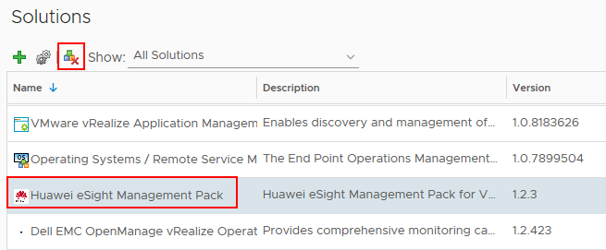

The **Warning** dialog box is displayed.



The uninstallation of the Huawei vROps plug-in is supported only on vRealize Operations Manager 6.2 and vRealize Operations Manager 6.6. This function is not supported on vRealize Operations Manager of other versions currently.

Select **I understand the risk and agree.**, and click **OK**.

The Huawei vROps plug-in is uninstalled.

----End

# Configuring an eSight Instance

3.1 Adding an eSight Instance

3.2 Modifying an eSight Instance

3.3 Deleting an eSight Instance

## Adding an eSight Instance

Set a whitelist.

By default, a whitelist of eSight northbound ports is configured. To add an eSight system properly, you must add the IP address of the server where vROps is located to the whitelist of eSight northbound ports.

1. Log in to the eSight WebUI.
2. Choose **System** > **Northbound Integration** > **Third-party System** > **Create**.

The **Third-party System** page is displayed, as shown in Figure 3-1.

Third-party System

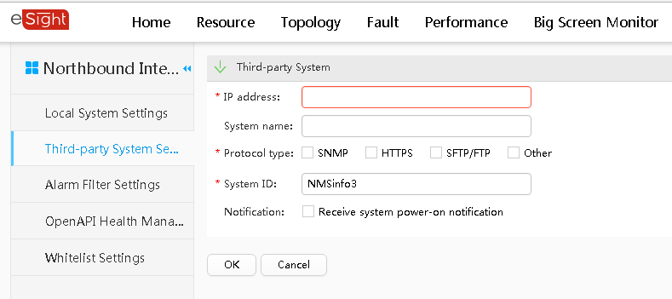

1. Set the following parameters:

* **IP address**: Set this parameter to the IP address of the vROps server.
* **Protocol type**: Select **HTTPS** and deselect other protocols.
* **System ID**: Retain the default value or enter a new value. The value can be an IP address or a string of 1 to 64 characters, including digits (0-9), lowercase letters (a-z), uppercase letters (A-Z), and special characters @_- (), .^$~`!.

1. Click **OK**.

The IP address of the vROps server is set as a whitelist, as shown in Figure 3-2.

Set successfully

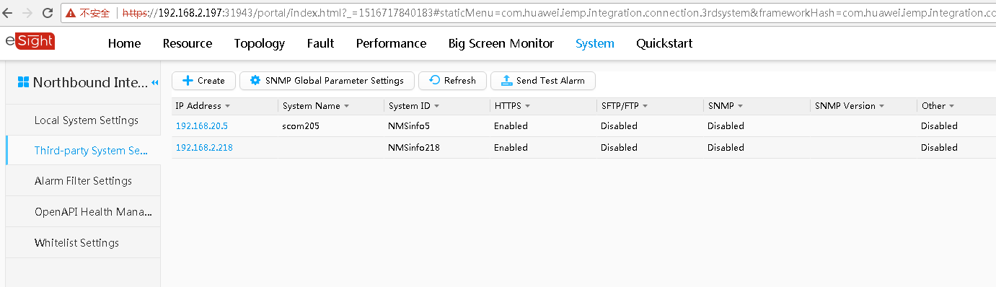

On the vRealize Operations Manager WebUI, select **Administration**.

The **Administration** page is displayed.

In the navigation tree, choose **Solutions**.

The **Solutions** page is displayed.

Select the Huawei vROps plug-in, and click .



The **Manage Solution - Huawei Server Management** dialog box is displayed.

In the **Instance Settings** area, set the following parameters, as shown in Figure 3-3.

Instance settings

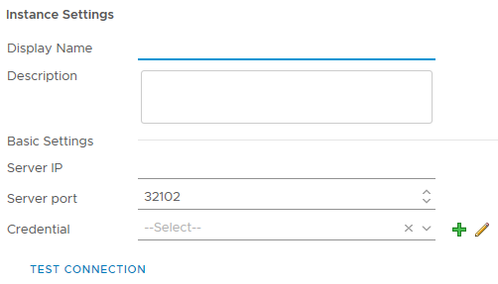

* **Display Name**: Set this parameter to a customized name. This parameter is used to identify the eSight instance.
* **Description**: Set this parameter to customized description, which provides supplementary information for the eSight instance.
* **Server IP**: Enter the eSight IP address.
* **Server port**: eSight port number, which is **32102** by default.

In the **Credential** row, click .



The **Manage Credential** dialog box is displayed.

Set the following parameters, and click **OK**, as shown in Figure 3-4.

Manage Credential

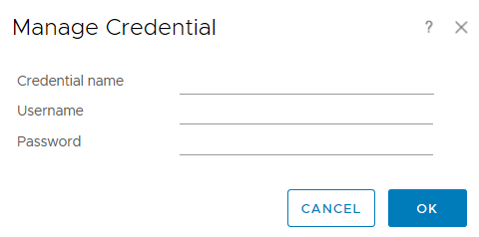

* **Credential name**: user-defined name to identify different credentials
* **Username**: username of the eSight open API to be added. The default username is **openApiUser**.
* **Password**: password of the eSight OpenAPI to be added. The default password is **Changeme_123**.

Click **TEST CONNECTION**.

* If the connection is successful, the dialog box indicating a successful test is displayed.
* If the connection fails, check whether the eSight IP address, port number, user name, and password are correct.
* If no, change the parameter values, and click **TEST CONNECTION** again.
* If yes, contact Huawei technical support.

Click **SAVE SETTINGS** to save the eSight configuration information.

A dialog box is displayed, indicating that the configuration information is saved successfully.

Click **OK**.

The eSight instance is added.

Click **CLOSE**.

On the **Solutions** page, view the data collection status of the eSight instance.

----End

## Modifying an eSight Instance

On the vRealize Operations Manager WebUI, select **Administration**.

The **Administration** page is displayed.

In the navigation tree, choose **Solutions**.

The **Solutions** page is displayed.

Select the Huawei vROps plug-in, and click .



The **Manage Solution - Huawei Server Management** dialog box is displayed.

In the navigation tree, select the name of the eSight instance to be modified, and determine whether to modify **Basic Settings** of the instance, as shown in Figure 3-5.

Modifying an eSight instance

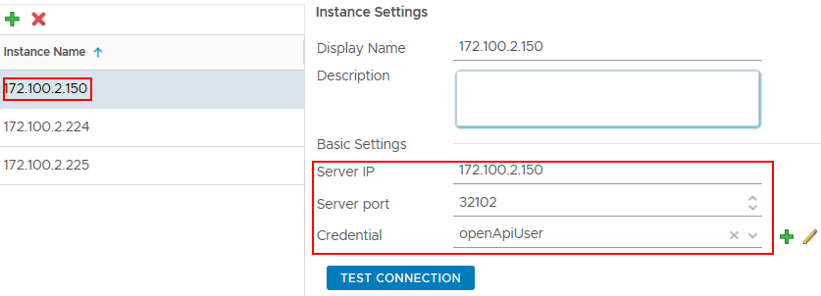

* If yes, perform Step 5 to Step 6.
* If no, go to Step 7.

Modify the following parameters, as shown in Figure 3-5.

* **Display Name**: Change the instance name.
* **Description**: Change the instance description.
* **Server IP**: Change the eSight IP address.
* **Server port**: Change the eSight port number.
* **Credential**: Click , and change the credential name, eSight user name, and password.



After an eSight instance is accessed, if the eSight port number, user name, or password is changed, you must synchronize the new port number, user name, or password to the vRealize Operations Manager system; otherwise, server management will be affected.

Click **TEST CONNECTION**.

* If the connection is successful, the dialog box indicating a successful test is displayed.
* If the connection fails, check whether the eSight IP address, port number, user name, and password are correct.
* If no, change the parameter values, and click **TEST CONNECTION** again.
* If yes, contact Huawei technical support.

Then go to Step 8.

Modify the following parameters, as shown in Figure 3-6.

Instance settings

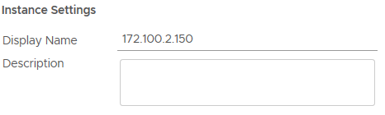

* **Display Name**: Change the instance name.
* **Description**: Change the instance description.

Click **SAVE SETTINGS** to save the eSight configuration information.

A dialog box is displayed, indicating that the configuration information is saved successfully.

Click **OK**.

The eSight instance is modified.

Click **CLOSE**.

On the **Solutions** page, view the data collection status of the modified eSight instance, as shown in Figure 3-7.

Collecting data

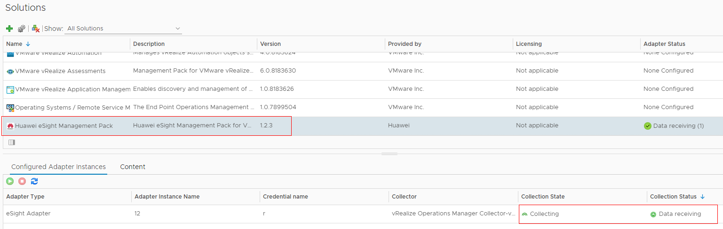

----End

## Deleting an eSight Instance

On the vRealize Operations Manager WebUI, select **Administration**.

The **Administration** page is displayed.

In the navigation tree, choose **Solutions**.

The **Solutions** page is displayed.

Select the Huawei vROps plug-in, and click .



The **Manage Solution - Huawei Server Management** dialog box is displayed.

In the navigation tree, select the name of the eSight instance to be deleted, and click , as shown in Figure 3-8.



Deleting an eSight instance

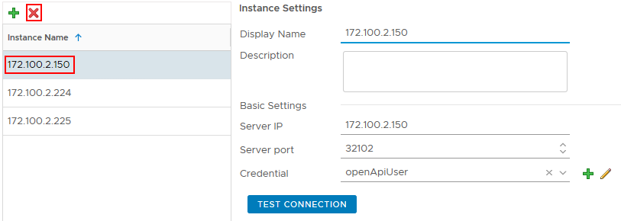

The **Confirmation** dialog box is displayed.

Select **Remove related objects.** (which is selected by default), and click **YES**.

The eSight instance is deleted.

----End

# Querying Server Information

4.1 Querying the Server List

4.2 Querying Component Information

4.3 Adding a Component View

4.4 Locating Alert Information

## Querying the Server List

On the vRealize Operations Manager WebUI, select **Environment**.

The **Environment** page is displayed.

In the navigation tree, choose **Huawei Server Management** > **Device Inventory tree**.

The **Device Inventory tree** page is displayed.

In the navigation tree, query the server list, as shown in Figure 4-1.

Device Inventory tree

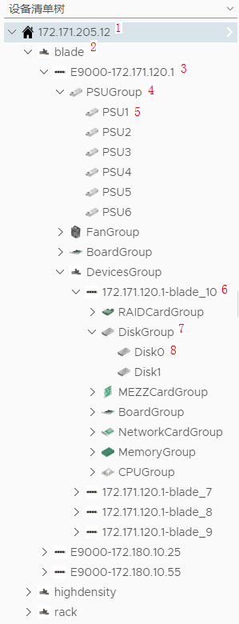

* 1: eSight IP address
* 2: Server type. **blade** indicates a blade server, **highdensity** indicates a high-density server, and **rack** indicates a rack server.
* 3: Server model and iBMC IP address
* 4: Component group
* 5: A component
* 6: IP address and slot number of a management module
* 7: Device group
* 8: A device

----End

## Querying Component Information

On the vRealize Operations Manager WebUI, select **Environment**.

The **Environment** page is displayed.

In the navigation tree, choose **Huawei Server Management** > **Device Inventory tree**.

The **Device Inventory tree** page is displayed.

Choose ***eSight IP address*** > ***Server type*** > ***Server IP address*** > ***Component group*** > ***Component to be viewed***, as shown in Figure 4-2.

Component information

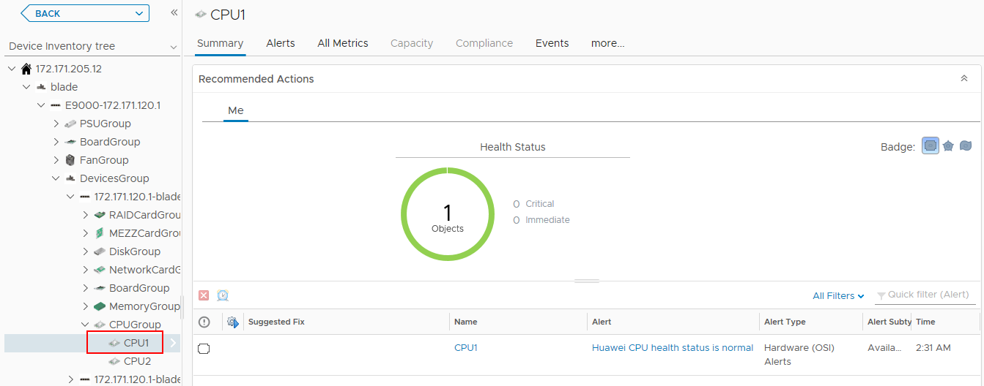

On the **Summary** tab, the component running status and alarm information are displayed.

Click **All Metrics**.

The **All Metrics** tab is displayed.

Choose **All Metrics** > **Health Status**, as shown in Figure 4-3.

Health status

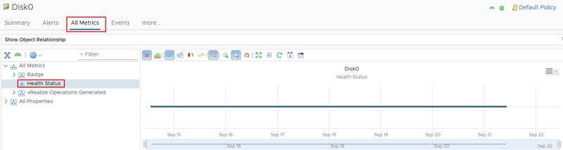

View the real-time status curve chart in the right pane.

----End

## Adding a Component View

On the vRealize Operations Manager WebUI, select **Environment**.

The **Environment** page is displayed.

In the navigation tree, choose **Huawei Server Management** > **Device Inventory tree**.

The **Device Inventory tree** page is displayed.

Choose ***eSight IP address*** > ***Server type*** > ***Server IP address*** > ***Component group*** > ***Component***, as shown in Figure 4-4.

Device Inventory tree

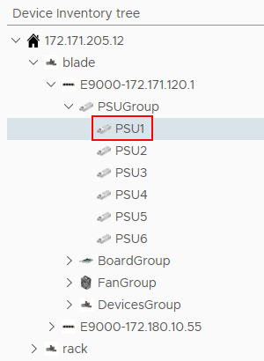

In the right pane, click **Details**.

The **Details** tab is displayed, as shown in Figure 4-5.

Details

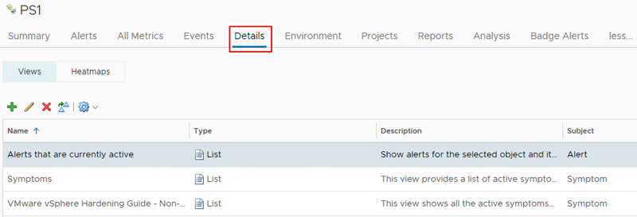

Click .



The **New View** dialog box is displayed.

In **Name and Description**, enter the name and description of the component view to be added.

In **Presentation**, select **List**, and preview the list in the right pane, as shown in Figure 4-6.

Presentation

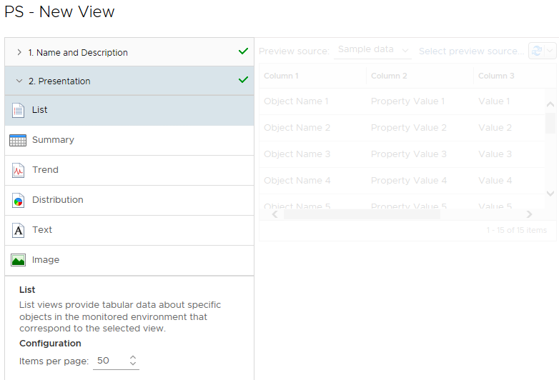

In **Subjects**, choose **eSight Adapter** > ***Component type to be added***. For example, to add a component view to PS1, choose **eSight Adapter** > **PSU**.

In **Data**, select **Metrics** or **Properties**, double-click the attribute marked by , and view the newly added attribute in the **Data** area, as shown in Figure 4-7.



Data

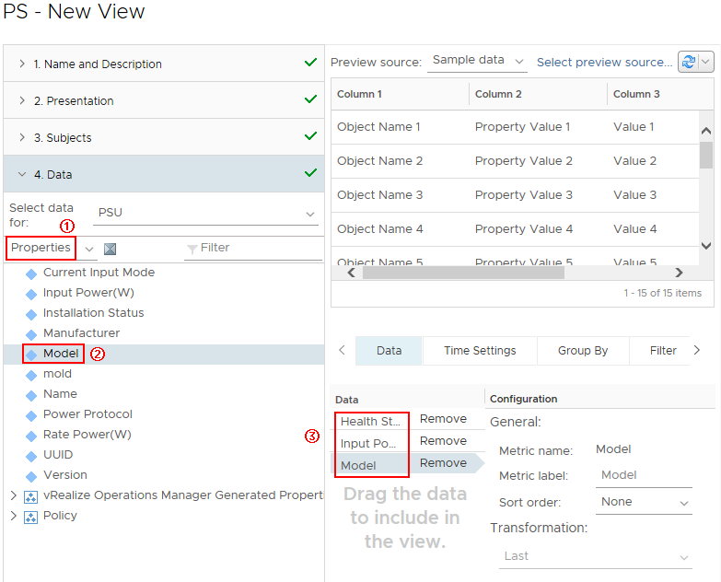

To delete an attribute, click **Remove** in the **Data** area. For example, to delete **Health Status**, click **Remove** in the **Health Status** row in (3).

In **Visibility**, retain the default settings, and click **SAVE**.

On the **Details** tab, view the newly added component view.

Select *Server IP address* in **Device Inventory tree**, choose **Details** > ***Newly added component view*** in the right pane, and view all views of this type of component of the server, as shown in Figure 4-8.

View

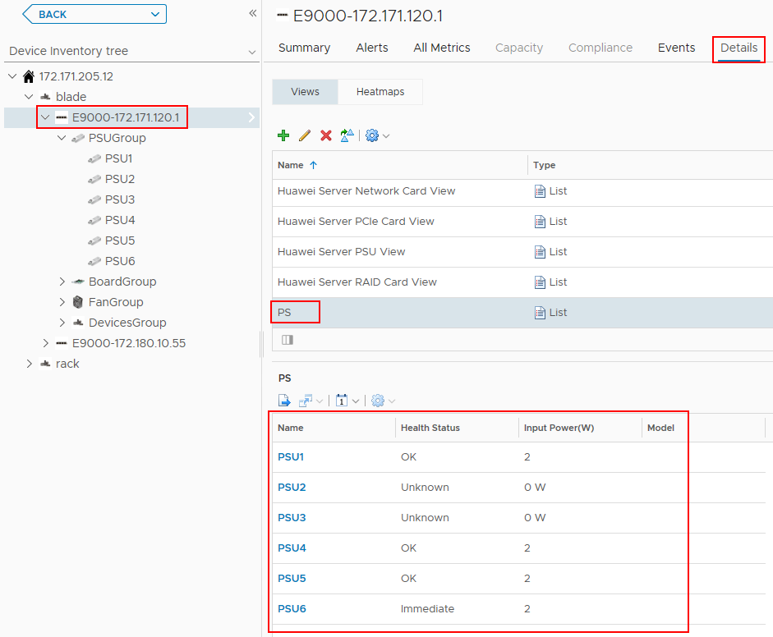

Select *Server type* in **Device Inventory tree**, choose **Details** > ***Newly added component view*** in the right pane, and view all views of this type of component of this type of server, as shown in Figure 4-9.

View

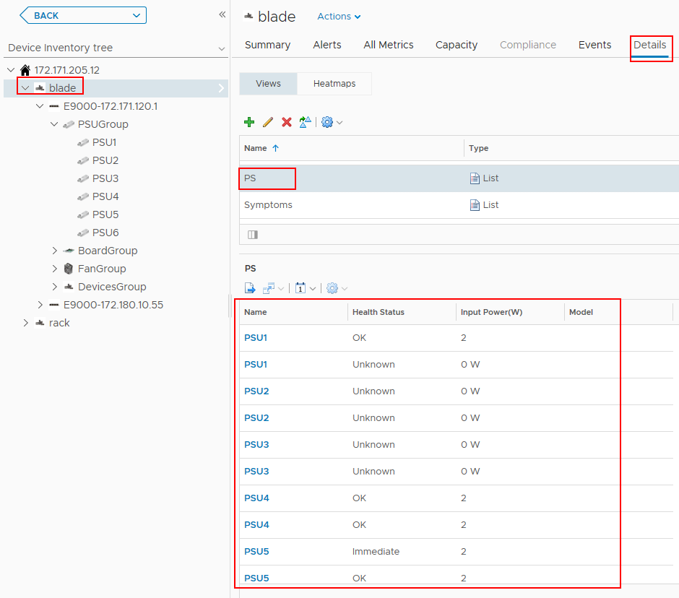

Select *eSight IP address* in **Device Inventory tree**, choose **Details** > ***Newly added component view*** in the right pane, and view all views of this type of component of the eSight system, as shown in Figure 4-10.

View

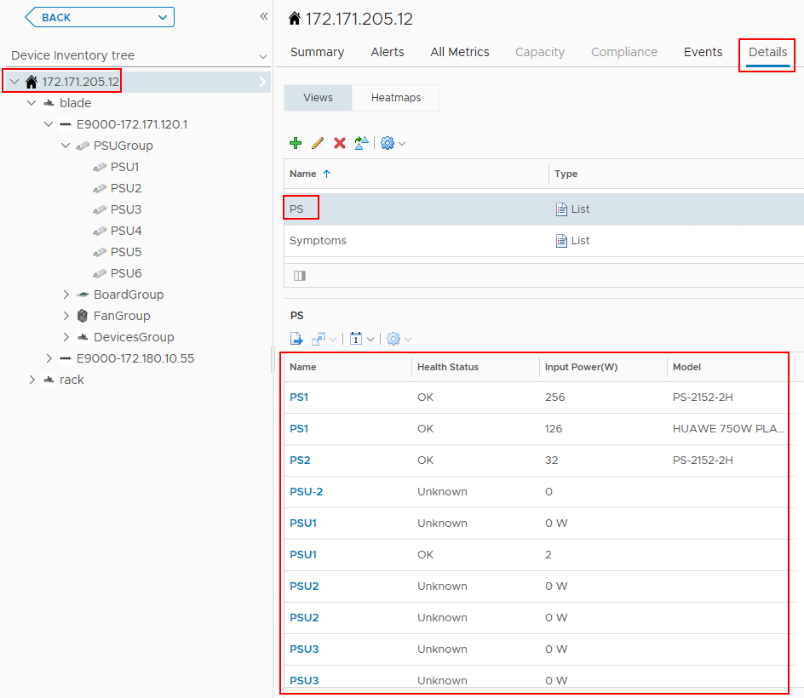

----End

## Locating Alert Information

On the vRealize Operations Manager WebUI, select **Alerts**.

The **Alerts** page is displayed.

In the navigation tree, choose **All Alerts**.

The **All Alerts** page is displayed.

In **Group By**, select **Object Type**.

In the alarm row of which the component is to be located, click *Trigger object*, as shown in Figure 4-11.



The trigger object can only be a component and cannot be a component group; otherwise, the server where the alarm is generated cannot be located.

All Alerts

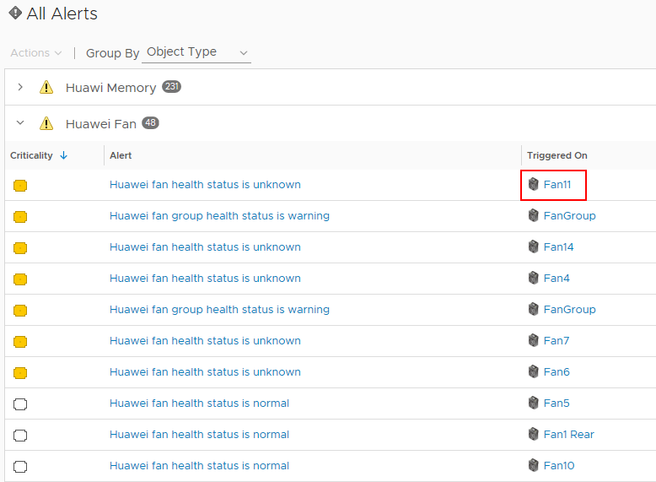

The trigger object information page is displayed, as shown in Figure 4-12.

Trigger object

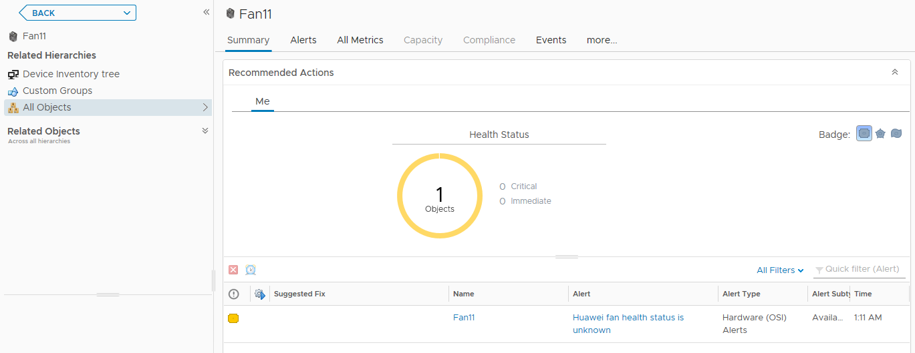

In the navigation tree, double-click **Device Inventory tree**.

The **Device Inventory tree** page is displayed, as shown in Figure 4-13.

Device Inventory tree

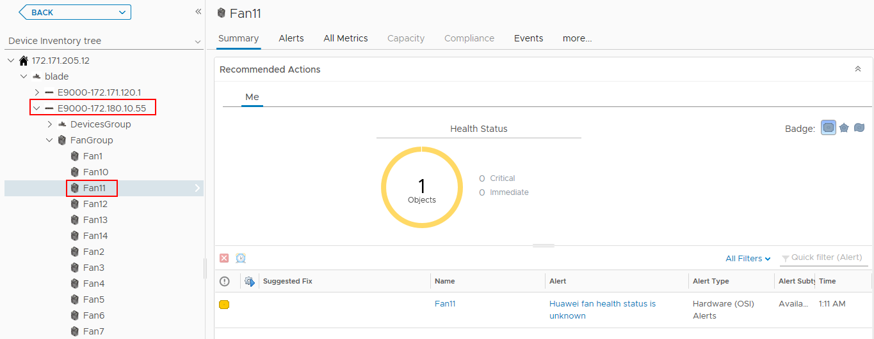

In the navigation tree, view the server to which the trigger object belongs.

----End

# Querying the Huawei vROps Plug-in Version

On the vRealize Operations Manager WebUI, select **Administration**.

The **Administration** page is displayed.

In the navigation tree, choose **Solutions**.

The **Solutions** page is displayed.

View the current Huawei vROps plug-in version, as shown in Figure 5-1.

Solutions

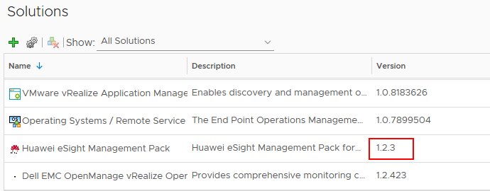

----End

# FAQs

6.1 Connection Test Failed When Adding an eSight

## Connection Test Failed When Adding an eSight

Symptom

After an eSight server is added, a failure message is displayed during the connection test.

Cause

* The user name or password is incorrect.
* The eSight northbound interface user is locked.
* A whitelist has not been set.

Solution

* The user name or password is incorrect.

Enter the user name and password of the eSight northbound interface user. To view the user name and password, perform the following steps:

* 1. Log in to the eSight WebUI.
  2. Choose **System** > **User Management** > **User**. The **User** page is displayed.

The role of the eSight northbound interface user is **Open API user group**, and the user name is displayed under **User Name**.

Viewing information about the eSight northbound interface user



* 1. Click to display the dialog box for resetting the user password.



Reset Password

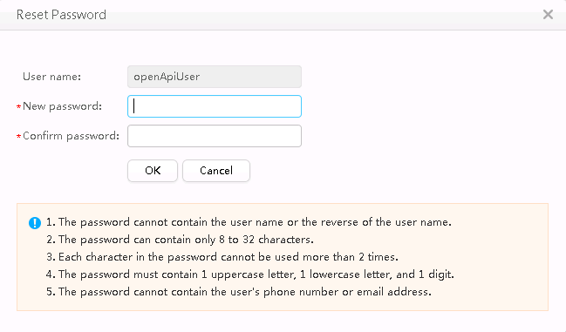

* 1. Enter a password in **New password** and **Confirm password**.
  2. Click **OK**. The password is reset.
* The eSight northbound interface user is locked.

To unlock a user, perform the following steps:

* 1. Log in to the eSight WebUI.
  2. Choose **System** > **User Management** > **User**.

The **User** page is displayed.

* 1. Click to set **Status** of the eSight northbound interface user to **Enabled**.



Unlocking a user



* A whitelist has not been set.

By default, a whitelist of eSight northbound ports is configured. To add an eSight system properly, you must add the IP address of the server where vROps is located to the whitelist of eSight northbound ports.

* 1. Log in to the eSight WebUI.
  2. Choose **System** > **Northbound Integration** > **Third-party System** > **Create**.

The **Third-party System** page is displayed, as shown in Figure 6-4.

Third-party System



* 1. Set the following parameters:
  2. **IP address**: Set this parameter to the IP address of the vROps server.
  3. **Protocol type**: Select **HTTPS** and deselect other protocols.
  4. **System ID**: Retain the default value or enter a new value. The value can be an IP address or a string of 1 to 64 characters, including digits (0-9), lowercase letters (a-z), uppercase letters (A-Z), and special characters @_- (), .^$~`!.
  5. Click **OK**.

The IP address of the vROps server is set as a whitelist, as shown in Figure 6-5.

Set successfully



# Getting Help

If you encounter any problems during routine maintenance or troubleshooting, contact Huawei technical support engineers.

7.1 Collecting Fault Information

7.2 Preparing for Debugging

7.3 Using Product Documentation

7.4 Obtaining Technical Support

## Collecting Fault Information

Before troubleshooting, obtain the following information:

* Customer company and address
* Contact person and telephone number
* Time when the fault occurred
* Detailed fault symptom
* Device type and software version
* Any measures taken and effects
* Fault severity and expected rectification deadline

## Preparing for Debugging

When you seek Huawei technical support, Huawei technical support engineers may assist you in performing some operations to further collect fault information or rectify the fault.

Before contacting technical support engineers, prepare the spare parts for boards and port modules, screwdrivers, screws, serial cables, and network cables.

## Using Product Documentation

Huawei provides the documents delivered with the equipment. This document provides guidance for you to solve common problems that occur during routine maintenance or troubleshooting.

To better rectify the fault, you are advised to use the guide before contacting Huawei technical support engineers.

## Obtaining Technical Support

Huawei's timely and efficient response is available from:

* Local branch offices
* Secondary technical support system
* Telephone support
* Remote support
* Onsite support

Technical Support Website

Obtain technical documents at [Huawei Technical Support](https://support.huawei.com/enterprise/en/index.html) website.

Self-Service Platform and Community

Learn more about servers and communicate with experts at:

* [Computing Product Information Service Platform](https://support-it.huawei.com/server/#/home) for specific server product documentation.
* [Huawei Enterprise iKnow](https://support.huawei.com/iknow/?source=SupportE) for quick learning about products.
* [Huawei Enterprise Support Community (Servers)](https://forum.huawei.com/enterprise/en/Server/forum/895) for learning and discussion.

News

For notices about product life cycles, warnings, and updates, visit [Support > Bulletins > Product Bulletins](https://support.huawei.com/enterprise/en/bulletins-product).

Cases

Learn about server applications at [Computing Case Library](https://support-it.huawei.com/server-knowledgebase/#/home).



The Computing Case Library is available only to Huawei partners and Huawei engineers.

Huawei Technical Support

If a fault persists after taking the above measures, obtain technical support in the following ways:

* Contact Huawei customer service center.
* Enterprise customers

Send emails to [support_e@huawei.com](mailto:support_e@huawei.com) or visit [Global Service Hotline](https://e.huawei.com/en/service-hotline-query).

* Carriers

Send emails to [support@huawei.com](mailto:support@huawei.com) or visit [Global TAC Information](https://support.huawei.com/carrier/docview!docview?nid=IN0000034614).

* Contact technical support at your local Huawei office.